Readme file :

*Employee Attendance system using face recognition*

**WHAT IS FACE RECOGNITION ?**

Facial recognition is a way of identifying or confirming an individual’s identity using their face. Facial recognition systems can be used to identify people in photos, videos, or in real-time.

**WHY FACE RECOGNITION ?**

There are many benefits facial recognition can offer society, from preventing crimes and increasing safety and security to reducing unnecessary human interaction and labour. In some instances, it can even help support medical efforts.

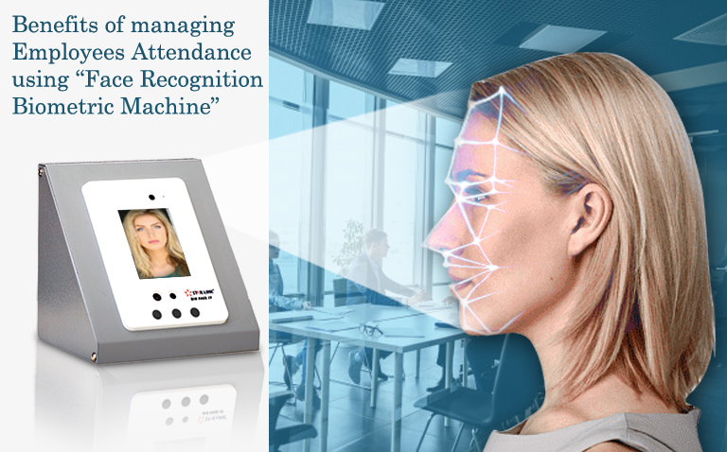

* **INDIVIDUAL TRACKING**
* **ACCURATE AND RELIABLE**

**FEATURES**

* Capture images
* Train these images during runtime
* Runtime dataset created
* Recognize and track these images for attendance
* Display attendance along with date and time.

**DEPENDENCIES AND TECH USED**

* BUILD WITH
* Python – 3.9
* MODULES USED – ALL ARE LATEST VERSIONS
* Tkinter – 8.6
* Opencv – 4.5.4
* os –
* pytest-shutil
* csv -1.0
* numpy -1.21.4
* pandas - 1.4.2
* PIL-8.4.0
* datetime – 4.4
* time
* urllib
* ssl(For SECURITY)
* SOFTWARE USED
* VS Code
* Git

**INSTALLATION**

**Download or Clone the project**

First Download or Clone the Project on Your Local Machine. To download the project from github press **Download Zip**

* **Use pip command for installation of python modules (pip install …. )**

**RUN CODE**

* Change path to directory path i.e where your folder after downloading gets located using cd command. (Eg . /admin/attendance_projs)
* Use python train.py command to run the code

**SOME OUTPUT SNAPS**

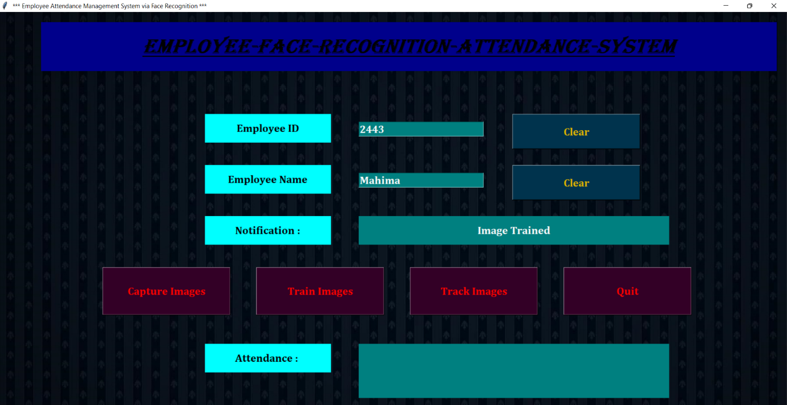

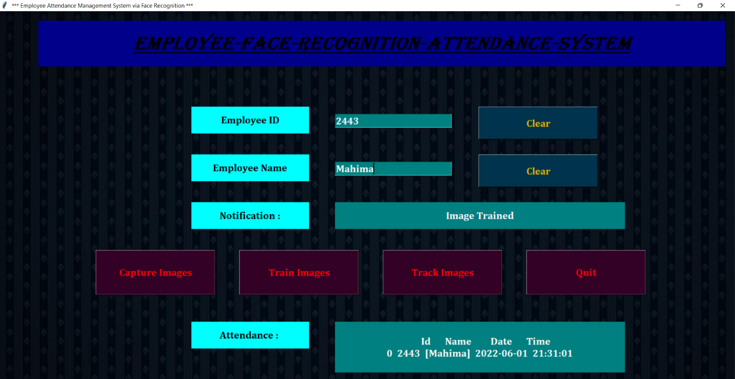

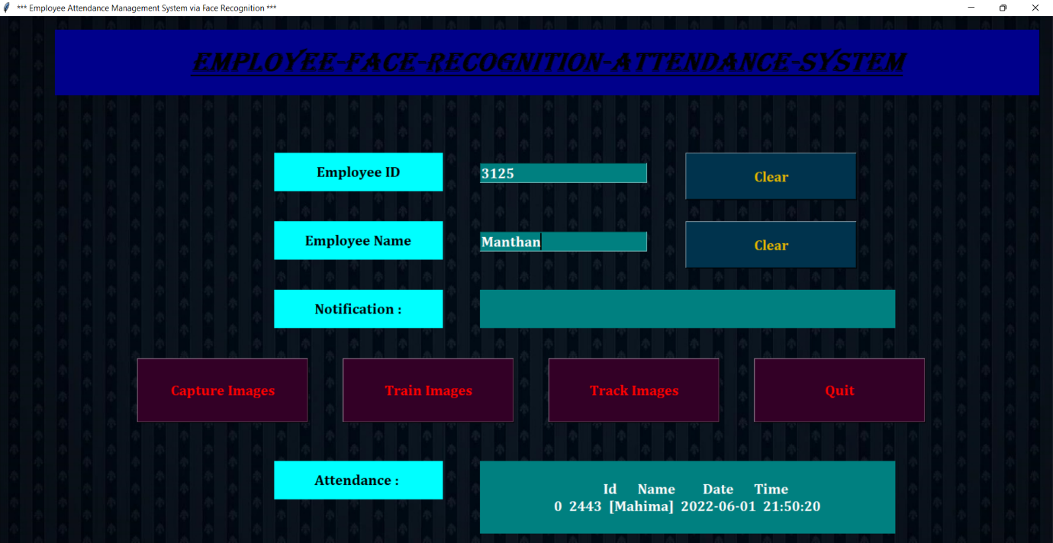

**WORKING/TEST CASES**

* Enter employee id and employee name when you register for the first time. Capture your image properly with the help of webcam. Press ‘q’ by keeping the cursor on the webcam screen.(Screenshot 1 & 2 )

Now train the images. Message of ‘Image Trained, is also displayed in the first message box (in front of Notification Label). When you click on track images, again the webcam will appear and you can see your face recognized by your id and name. Press ‘q’ on the webcam screen and your attendance will be marked.

* When you want to mark your attendance further again, you just need to enter your employee id and employee name and click on track images after which webcam will appear with your name and id displayed. By pressing ‘q’ on the webcam screen, your attendance will automatically be recorded. There is absolutely no need of capturing and training the images again.
* Now, if you enter an other employee id and name which is already registered before and try to mark their attendance by clicking on track images, you will find that the webcam recognizes your face as your own and your attendance with your name and id will be marked, not of the other employee. (As in Screenshot 3)
* In the video clip shared, point 3 was demonstrated directly.
* For the whole demonstration, I have uploaded the Video Demonstration Part 2 clip which is just a 2 minutes video and demonstrates all the test cases.

*THANKYOU!!*